Wise Words - Teams of History
Gary Wise
With New York upon us, this week's Wise Words takes a nostalgic look back at the Pro Tour's greatest teams and what made them click. I chose the teams based on historic importance, longevity and achievement. I didn't take a close look at European Alliance or the Jumble because of their large and constantly changing rosters.
Pacific Coast Legends (PCL) - Mark Justice, Mark Chalice, Henry Stern, Scott Johns, Preston Poulter, Mario Robaina, Frank Gilson, Scott Burke, George Baxter
The originals. PCL actually formed before the Pro Tour did, not looking at Magic as a profession so much as a competitive community that their combined efforts could potentially dominate. The team was founded by California residents Chalice, Stern, Robaina and Gilson and quickly became the best-known team on the planet, with their influence being felt through newsgroup postings and the like when the Magic community was still being built from the ground up.

The team seems to have been founded as a way of sharing ideas with one another and friendship than anything else...
Once the Pro Tour actually began, PCL didn't actually do that much. Justice and Stern both lost to Tom Champheng the Top 8 of 1996 Worlds, Poulter had his two early Top 8s and Justice also placed Top 8 at the first Tour, but the team was obviously starting to struggle, and even the injection of Johns after 1996 Worlds didn't do much to help. When Justice decided that the split on his winnings was too steep after his second-place finish at Pro Tour-Paris, the team was disbanded.
Within the confines of the team, where most teams have individuals with clearly defined roles, the Legends did not. Chalice and later Johns did most of the deck design, but everyone contributed, with Robaina often providing inspiration for those decks. Where most teams rely on their best players to also serve as leaders, while Justice, Stern and Poulter were putting up early results, it was the more level-headed Gilson and Mario who offered the voice of reason when egos and tempers flared.
The team seems to have been founded as a way of sharing ideas with one another and friendship than anything else, and when founding member Stern left for an R&D job and the Johns addition turned the team's attitude towards a more professional tone, it seemed to spell the end. Still, the PCL name should be remembered as the one that set the tone for the teams of the future.
Hitmen - Brian Hacker, John Yoo, Truc Bui, Jason Zila
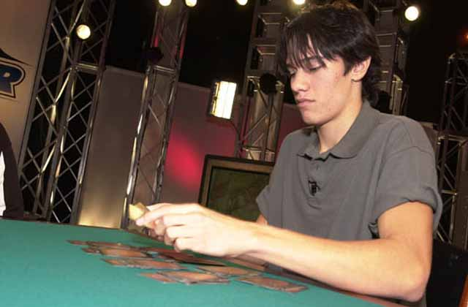
Jason Zila re-emerged for a second-place finish at last year's Masters in New York
PCL's rise in the west didn't go unopposed. Just a few hours away, the Hitmen were forming their little team, and while it may not have had as high a profile, their legacy may be the longest-lasting of any of their peers. Composed of just four members, the Hitmen did everything together and were seemingly inseparable while they were on Tour.
These Californians will be best remembered for two things: the attitude they brought to the table and the drastic effect their efforts had on Limited play. The four of them were seen time again beating down opponents amidst a flurry of fun and trash talk. They took Limited to new levels and took a number of players with them, completely transforming the environment accompanying them as they did so.
For those of you not impressed with such antics, you can think of the Hitmen as the fathers of modern Limited play. Did they create draft? No, but before the Hitmen, Limited strategy went about as far as knowing which were the power cards. Truc Bui approached the table with the understanding that each of his creatures must attack each turn if able, and all of them seemed to understand where others didn't that tempo was as important, if not more so, than power. It was these four who really informed the world that as with Constructed, a Limited deck had to be built with goals and purpose, and that the sum of the parts did not necessarily add up to the value of the whole.
Deadguy - Chris Pikula, Dave Price, Worth Wollpert, Dave Bartholow, Tony Tsai, Matt Place, Jon Finkel
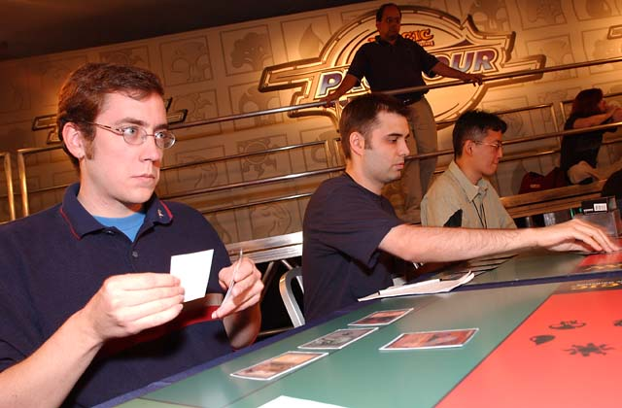
Dave Price
Meanwhile, on the east coast, Chris Pikula, Dave Bartholow and Dave Price were making the choice to attend Cornell, eventually meeting at the school's gaming society, leading to formation of the golden era's third great American team, Deadguy. The three quickly became friends, working together on every format in the game while hanging out away from Magic as well. A year later, Tony Tsai started attending the school and the formation of the team became a foregone conclusion.
Deadguy didn't make their mark immediately, but the strong performances lasted longer than most. Pikula, who originally came from the midwest where he and Matt Place became the most feared players in the region, made consecutive Top 8s at PT-Atlanta and Dallas. Worth Wollpert, who more or less joined the team at PT-Columbus, consistently made Top 16s before finally achieving a Top 8 finish at 1999 PT-LA. Price became well-known as the king of the qualifiers, finding a way to qualify for each Pro Tour before being sent back to the PTQs, finally seeing it pay off with his win at 1998 PT-LA, while Place, who won Mainz, hooked up with his old adversary Pikula, and joined the team soon after.
The last addition to Deadguy was probably the most notable, with Jon Finkel, long a junior hanger-on, joining the squad's official ranks before his first PT win at NY '98. Pikula had already been calling Jon the best player in the world, so the addition came as no surprise. Unfortunately, the ultimate addition would come as the originals were graduating from university, leaving Magic on the back burner for most.
With regards to how the team operated, Pikula and Bartholow would build separately from Price, who in Pikula's words would "only build beatdown decks". It was their multi-pronged approach that the members credit with their success. With their popularity still intact as evidenced by Price and Pikula's election to the Invitational, the Deadguy legacy lives on.
Lotus Noir - Cyrille De Foucaud, Marc Hernandez, Bertrand Lestree, Clementine Bagieu
The first great European team, this band of Frenchmen's greatest influence was felt before the Pro Tour's invention, providing the example from which Europe's finest would spring. Lestree, probably the best-remembered member of the team, is no longer active, but stories of his exploits, ranging from coming second at 1996 PT-NY to punching out a judge live on.
As for the other members, De Foucaud still appears at major events from time to time, though he isn't as dominant as he once was, while Hernandez, who lost the final of World Championships '95 to Alexander Blumke, still frequents the Pro Tour, both as player and as judge. Clementine was the first woman to finish Top 64 at a PT.
Tongo Nation - Mike Long, David Mills, Pete Leiher, Donnie Gallitz, Chris Bishop, Dominick Crapuchettes, Jon Becker, Brian Schneider, Justin Schneider, Jeff Donais, cast of thousands.
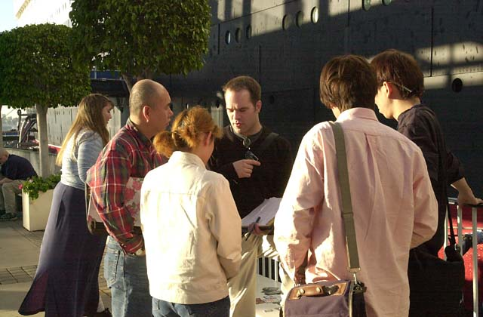
And then there were the villains. Love 'em or hate 'em, the Tongo's probably wanted the latter, using their reputations to help their games. After Pro Tour-Dallas, Don Gallitz and Mike Long were on their way home discussing what was enabling certain players to do as well as they were, and agreed to form a team. Long contacted TNC and struck the best sponsorship deal of all time, and soon the team was formed, with the originals being Mike, Don, Mills and Leiher.
"The key to Tongo" says Gallitz "is that behind the big four who got the credit were like twenty more guys who were helping us build and test decks. Mills would theorize, Pete was the hardcore tester and Mike, Brian Schneider and I did a lot of the building. We all complimented one another really well, and having those twenty extra bodies made it so everything got done. The Nation was an entire community."
The Nation left its mark, with Mills's two finals appearances at LA and Chicago, Long's win at Paris and a number of other strong performances, but ultimately, when the sponsorship deal dried up, the clashing of strong personalities at the team's highest levels led to the end. Before that demise though, they left their mark, with their accomplishments exceeded only by the feuds cultivated with Deadguy and the like.
Your Move Games - Darwin Kastle, Dave Humphreys, Rob Dougherty, Michele Bush, Justin Gary, cast of thousands.
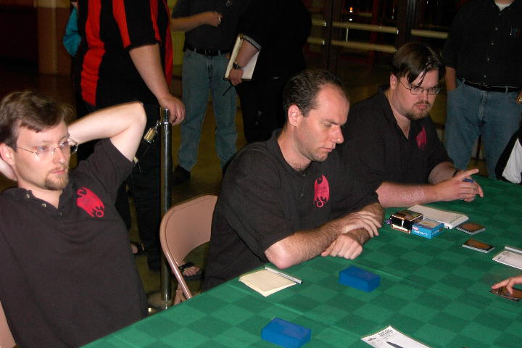
Arguments could be made that some things get better with age. While this last one wasn't exactly YMG's banner year, it did continue to enforce the idea that Rob Dougherty is every bit as good as his teammates have long claimed him to be. The Boston store team's peak came two years ago when they won the first team PT at DC, but as their recent win in Columbus proves, they're still going strong.
A lot of you probably don't need the rundown on these guys. Darwin has five Top 8 finishes and is one year removed from his win at GP-Manchester. Rob, with his Top 8 in Chicago, now has three final day appearances, while Humphreys, whose resume may not be as impressive as Kastle's, is still probably the most feared player in Massachusetts. Justin Gary is still one of the most consistent players on the Pro Tour, with only one Top 8 to show for his many Top 16 finishes, while Michelle, probably the best known female player in the world today, made history not too long ago with her second place finish at GP-New Orleans.
With Darwin and Rob full-time and Humphreys more or less the same, this team, who often draws from the rich soil that is the Boston area Magic community, has shown their consistency to be their mark of excellence. That, more than anything else, is the best reason to assume that excellence will be seen on Tour for years to come.
CMU - Randy Buehler, Erik Lauer, Mike Turian, Dan Silberman, Brian Schneider, Pat Chapin, Nate Heiss, Aaron Forsythe, Andy Johnson, Andrew Cuneo, Eugene Harvey, John Rizzo, cast of Thousands.
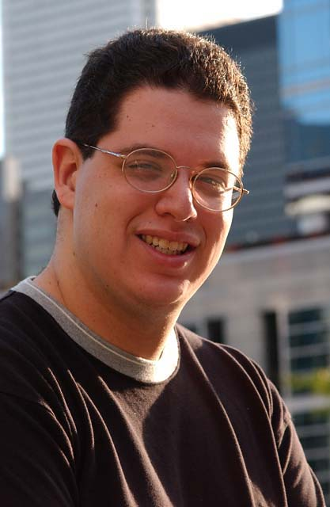
When Randy Buehler qualified for Pro Tour-Chicago, he and Eric Lauer had already been working together for a long time. At local tournaments, two high schoolers, Mike Turian and Dan Silberman each introduced themselves to the grad school attendees, informed them that they would each be attending CMU in the fall. The group immediately started working together and finally piled into one car for a road trip to their first test: GP-Toronto.
The results were staggering. Turian, Lauer and Silberman each made Top 8 in Toronto, and while none of them came away with first place, it was pretty obvious to all involved that something special had been cultivated. Tony Tsai dubbed the group 'Team CMU', and with nothing better to call themselves, the name stuck. Soon after, Randy won Pro Tour-Chicago, and there was a new power at the game's elite level.
CMU has gone through transformations over the last four years, with Buehler graduated to R&D and Lauer no longer competing, but they're far from dead. Turian, now a little older, a little wiser and a lot more successful, still perseveres, with the new generation also including Andy Johnson, Andrew Cuneo and Aaron Forsythe, who combined their efforts to take second at PT-NY a year ago, as well as a number of the supporting members like John Rizzo and Nate Heiss who were not included on the original because of sponsorship prospectus. Pittsburgh is flush again.
The key to CMU has always been the hours they put in, gathering daily in days of old, living together in days of new. The team as it stands has made up for the loss of Buehler and Lauer by maintaining their work ethic, allowing for major successes at last year's U.S. Nationals and this year's Worlds.
Mogg Squad - Scott Johns, Alan Comer, Brian Selden, Sigurd Eskeland, Jakub Slemr, Gary Wise, Zvi Mowshowitz
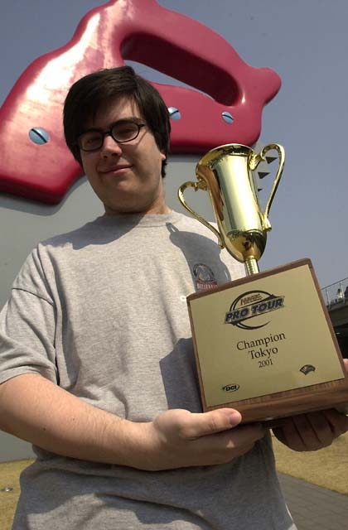
With PCL defunct, Scott Johns needed a new team to test with, and contacted California old-schooler Alan Comer. The two started working together loosely before heading to off to a Tour in 1998, where Alan and I, once acquainted with one another through the Legion mailing list, started talking, leading up to their sharing their decklist for LA with me.
From there, things were pretty simple. Alan, Scott and I worked together leading up to Worlds that year, where the three of us roomed together, working with other former legionnaire Jakub Slemr and my old friend Sigurd Eskeland, as well as a kid from San Diego they brought with them. The kid turned out to be Brian Selden, who won the World Championship, and soon after it was agreed that the team's formation was in order.
As well as the Squad did over the next year, it was the eventual addition of Zvi Mowshowitz that made things click. The combination of Zvi and Scott gelled to create some of the best decks seen over the last few years, with the entire team seeing the benefits. All told, all but one member has won a Pro Tour, with Comer, the only one lacking a title, making five third-day appearances.
The Squad's lasting legacy is it use of the internet, the first major Pro Tour force to do so. With members in California, Norway, the Czech Republic, New York and Canada, the team used IRC, Apprentice and NetDraft as home base for playtesting. Teams like the Jumble and European Alliance have since followed suit as the planet gets smaller.
That's about it for this week. Here's hoping you enjoy the New York coverage, and perhaps gained an insight into how to make your team function a little better. Have a good one.

